

**Asia Pacific College**

Humabon, Makati, 1232 Metro Manila

Hotel Spa Reservation System

Midterm Project in CSPROJ

Submitted by:

Giomar T. Andres  
Gene Carlo A. Bongat  
Antonio Salvador S. Garinga  
Edward Joseph R. Mandac  
Gabriel Angelo A. Ngceen  
Caryl Johanan C. Orosco

MI – 153

Table of Contents

**List of Figures, List of Tables, List of Notations** 4

**Abstract**

Introduction

Project Context4  
Purpose and Description5  
General Objectives5  
Specific Objectives5  
Scope and Limitations of the Study6

**Review of Related Literatures/Systems**

Local Literatures7  
Foreign Literatures7-10

**Technical Background**

Programming Language11  
Resource Requirements

Hardware Requirements11  
 Software Requirements11  
 Human Resource Requirements11

**The Existing System**

Company Background12  
Data Flow Diagram13-14  
Problem Areas14

**The Proposed System**

Process Specification

Data Flow Diagram15-16

Data Specification

Entity Relationship Diagram17  
 Class Diagram  
 Object Diagram  
 Data Dictionary18  
 Tables/Files Layout19

Screen/Layout Specification20

**Methodology, Results and Discussions**

Requirement Documentation

Use Case Diagram21  
 Fully Dressed Use Case22-23  
 Activity Diagram24-25  
 Sequence Diagram26

Gap Analysis26

**Bibliography**27

**List of Figures, List of Tables, List of Notations**

* Data Flow Diagram – Existing and Proposed System (pages 13 – 16)
* Data Dictionary (page 18)
* Use Case Diagram (page 21)
* Fully Dressed Use Case (pages 22 – 23)
* Activity Diagram (pages 24 – 25)
* Sequence Diagram (page 26)
* Gap Analysis (page 26)
* Entity-Relationship Diagram (page 17)

**INTRODUCTION**

**Project Context**

The Asmara Spa's booking process, according to their client, is all manually performed. The researcher's task is to create a reservation system for the spa that will automate the process of booking an appointment and include an online reservation system for potential customers who are looking to book a reservation at the Asmara Spa via the internet.

To book a reservation in the Asmara Spa, each customer will have to inquire first about what services are available, and what are the available time slot/s on a certain date. Logically thinking, a treatment room has its own timetable which determines its availability for a reservation. Since the Asmara Spa has multiple treatment rooms, each time slot can be booked, as long as there is still an available treatment room. All of these data that the Spa was previously handling manually, will be handled by the system in real-time as to prevent conflicts in the booking process and provide accurate data in each report.

**Purpose and Description**

The purpose of this project is mainly to provide the client, Asmara Spa of Taal Vista Hotel, a reservation system for their spa that will automate most of the processes in their working environment. With manual work processes, many errors can occur that will waste time, lose efficiency, and possibly drop customer satisfaction rates which will, in return, reduce the amount of customers of the spa.

The reservation system shows the availability of the spa's services and the available schedules of their treatment rooms by using the data stored within the system, such as previously scheduled appointments to produce accurate information about schedule and service availability. The system also utilizes a web interface for users who want to book a reservation but isn't a guest checked-in at the hotel. After the system has processed the reservation, the spa staff assigned to that reservation is informed of the details of the reservation such as the time and date, what room will be used, and what service will they provide.

**General Objective:**

To create and implement an efficient reservation system for the client that automates their work processes. The system's efficiency is measured through the reports generated as it shows how many bookings are made daily.

**Specific Objectives:**

1. To address the mistakes that occur from doing manual work processes. For instance, a wrong date is written on paper or one of the services requested isn't indicated.
2. To eliminate instances of conflict in booking appointments.
3. To reduce the amount of time and resources needed in the booking process.
4. To generate a report that would show spa trends which shows how many bookings are made per day, what is the most demanded service,   
   and what are the peak hours and days.

**Scope and Limitations of the Study**

The proposed system will potentially be able to handle appointment requests from hotel guests, walk-in customers, and online requests. The system automatically assigns customer appointments to the spa's function rooms and potentially avoid overlapping appointments. It also handles the automation of assigning staff members to their respective function rooms. This system does not cover payment transactions and doesn't cover the staff's attendance as it is handled by the HR department.

It is assumed that the price of the service will depend on the service's duration. Also, the staff members are well-rounded and has their own fixed schedule to provide the services.

.

**REVIEW OF RELATED LITERATURE/SYSTEMS**

**Local Systems**

* **CHI: The Spa at Shangri-La**

CHI, The Spa at Shangri-La draws inspiration from the origins of the Shangri-La legend, a place of personal peace, enchantment and well-being. Shangri-La Hotel, Edsa, brings to Manila CHI, The Spa, a private sanctuary of calm, personal space and timelessness in a "spa within a spa" concept.

*(*[*http://www.shangri-la.com/manila/edsashangrila/health-leisure/chi-the-spa/*](http://www.shangri-la.com/manila/edsashangrila/health-leisure/chi-the-spa/)*)*

* **Zensoft Spa & Salon Management System**

ZenSoft is an IT company here in the Philippines which is specialized in developing software for the service industry. ZenSoft is an all-in-one online software specially built for salons and spas. Whether you have a small spa or multi-branch salon, you can use this software. It’s easy to use, cloud-based, intuitive, and robust.

*(*[*http://zensoft.ph/*](http://zensoft.ph/)*)*

*Features:* customer database, employee management, appointment management

**Foreign Systems/Literature**

* **Agilysys**

Spa Management is the nearly effortless software solution that simplifies the appointment process, enhances the guest experience and helps maximize the value of your spa as a revenue center. The software can stand alone or integrate seamlessly with your Agilysys Property Management System. Spa staff are provided with a detailed list of appointments scheduled, checked in, completed, or on hold. It provides real-time updates for error-free scheduling, tracks guest preferences for up-sell opportunities, creates staff profiles, and delivers increased efficiencies in inventory control. Beautifully simple.

*(*[*http://www.agilysys.com/solutions/by-products/activity-scheduling/spa-management*](http://www.agilysys.com/solutions/by-products/activity-scheduling/spa-management)*)*

*Features:* real-time updates, employee management, appointment management

* **Envision Spa System**

Envision contains three features mainly, Smart Management Tools, Marketing and Online Booking that make it easier and a lot more convenient for both the customer and staff from management to marketing, retailing and reporting. Envision provides all the necessary tools to grow a business. Envision keeps transactions easier, convenient and smooth while still providing enough man power for other task.

*(*[*http://www.envisionsalon.com/*](http://www.envisionsalon.com/)*)*

*Features:* online booking (either through website or through Facebook)

* **MindBody Spa System**

The MindBody Spa system has eight features in it that benefits both business owners and clients. It can be used in a computer and can also be downloaded in Play Store (for Android users) and App Store (for iOS users). The features are marketing, online booking, automation, point of sale, client tools, staff resources, and lastly, reports.

*(*[*https://www.mindbodyonline.com/spa*](https://www.mindbodyonline.com/spa)*)*

*Features:* online booking, customer database, employee management, real-time updates.

* **SalonLite**

SalonLite is a fully optimized cloud solution built with the latest technologies that provides a robust and secure scheduling solution for salons and spas around the world. SalonLite is a quick and easy solution that can be set up and fully functional within a few minutes.

*(*[*https://www.salonlite.com/*](https://www.salonlite.com/)*)*

*Features:* appointment management, online booking.

* **Springer-Miller Systems: SpaSoft**

SpaSoft Spa Management Software is a user-friendly system that facilitates total spa and activity management. As a result, your staff is empowered to provide impeccable service laser-focused on each and every client. SpaSoft interfaces with various systems – including hotel property management systems, credit card and gift card processors, back office systems, membership billing, and other technologies – to create a seamless flow of guest-centric information.

*(*[*http://www.springermiller.com/solutions/hotel-resort-spa/*](http://www.springermiller.com/solutions/hotel-resort-spa/)*)*

*Features:* integration into hotel systems, online booking, customer database

* **The Impact of Online Reservation Systems**

This study shows how online reservation systems impact the growth of a restaurant. Online reservation systems are one of the many possible ways to get their name out there in the market. You will also have the system to run the business smoothly. The connection of this study to the proposed project is that online reservation systems allow business to run smoothly. Online reservation is much more convenient than manual reservation. Online reservation means that you know the available schedules. While in walk-in, there is a possibility that there are no available schedules.

*(*[*http://scholarworks.umass.edu/cgi/viewcontent.cgi?article=1278&context=gradconf_hospitality*](http://scholarworks.umass.edu/cgi/viewcontent.cgi?article=1278&context=gradconf_hospitality)*)*

* **The Acceptance of Online Booking System (OBS) Based on the Theory of Reasoned Action**

This study shows the acceptance of online booking systems (OBS). OBS provide services with much less time and effort rather than manual booking systems (MBS). The researchers made an experiment to see if OBS is more preferred than MBS. The result of the experiment shows that OBS is easier, and more useful than MBS. In correlation to the proposed system, OBS tend to be more user friendly than other choices. It is easier to use and it will get the job done with less time and effort.

*(*[*https://pdfs.semanticscholar.org/c2bd/464eb3b3971049fc126d4ad748e50a6f4ed2.pdf*](https://pdfs.semanticscholar.org/c2bd/464eb3b3971049fc126d4ad748e50a6f4ed2.pdf)*)*

* **A Study on the Effects of Online Appointment Systems on Patients and Hospitals**

This is a study on how online appointment systems affect patients and hospitals. As many people have smart phones, the number of patients that use smart phones also increase. A study was conducted on the effect of online hospital appointment system to patients. Specifically, satisfaction of the patient after the usage of the system. According to the findings, it increases satisfaction of the patients so it also increases efficiency of work and profit of the hospital. The result of the research states that the system has a good effect on the treatments and profit of the hospital.

*(*[*https://www.ripublication.com/ijaer16/ijaerv11n14_22.pdf*](https://www.ripublication.com/ijaer16/ijaerv11n14_22.pdf)*)*

**Common Features of Related Systems**

* **Online Booking** 
  + Offering the option of online booking to customers gives them freedom to schedule at their own convenience, even after the spa’s working hours. A system that runs 24/7!
* **Appointment Management**
  + Relatively easy checking of availabilities (rooms, schedules, employee, etc.) and a quick way to book appointments.
* **Real-time Updates**
  + Manage bookings and availabilities with ease whilst avoiding the possibilities of any errors/conflicts in bookings.
* **Employee Management**
  + Clock-in/Clock-out, management of their schedules, to maximize their work hours.
* **Customer Database**
  + Storing guest profiles, identifying new and returning customers, and monitoring account balances.
* **Integration into Hotel Systems**
  + Retrieving list of hotel guests who are checked-in for ease of registration in the customer databases.

**TECHNICAL BACKGROUND**

**Programming Language**

The program is built purely in the platform Yii 2, an open source PHP framework. The database is built on MySQL.

* + - **PHP -**is a server-side scripting language designed primarily for web development but also used as a general-purpose programming language.

**Resource Requirements**

**Hardware Requirements**

* + - **CPU –** Intel Pentium Core 2 Duo
    - **Disk Space** – 1 GB
    - **RAM –** 1 GB

**Software Requirements**

* + - **Web Service** – Nginx Server or Apache Server
    - **Database Server -** MySQL
    - **Browser –** Internet Explorer, Microsoft Edge, Mozilla Firefox, Google Chrome or Safari
    - **Operationg System –** Windows, Linux or MAC OSX

**Human Resource Requirements**

* **Receptionist** - will be the one to use the system in the front desk.

**THE EXISTING SYSTEM**

**Company Background**

In early 1935, then Commonwealth President Manuel L. Quezon expressed interest in developing Tagaytay as a tourist destination. In 1939, the Zamoras of Manila Hotel built Taal Vista Lodge along “Ilong Kastila”—a stretch of flatland perched atop an incline which people said resembled a nose.

During the Second World War from 1942 to 1944, Taal Vista Lodge was converted to an officers’ quarters for the Japanese. In February 1945, the 11th Airborne Division of the US Army assist the liberation of Manila. Between 1956 and 1964 Tagaytay began to bepromoted as a major tourist destination in the Philippines with Taal Vista Lodge. One of the many regular visitors of the hotel was a young man who often chose one spot on the grounds from which to gaze out and dream. He is Henry Sy of SM Investments Corporation—the company that would later acquire Taal Vista Hotel.

In 2002, Taal Vista Hotel was reconstructed in the style of the original lodge. facilities and amenities were added for business and leisure activities. In 2004, after its renovation, the Hotel welcomed back its guests. Today, Taal Vista Hotel remains a landmark deeply entrenched in the history and heritage of Tagaytay City.

**Data Flow Diagram**

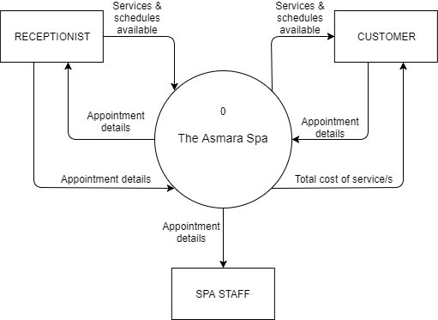**Context Diagram**

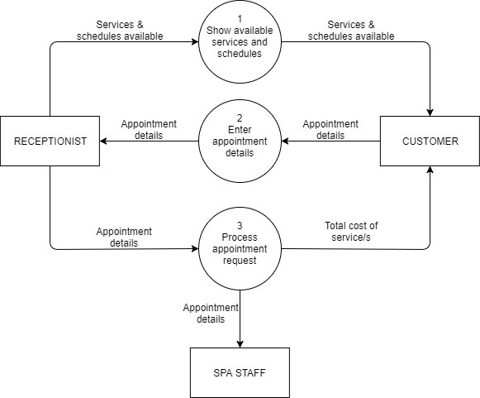**Level 0**

**Level 1 DFD for Process #3**

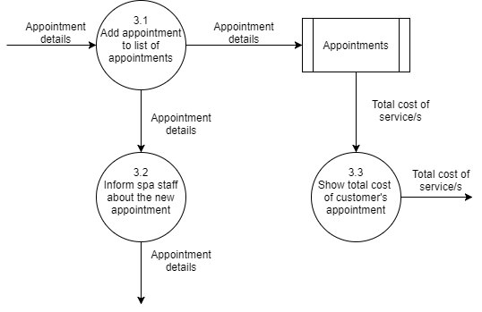

**Problem Areas**

The problem of the existing system includes manual work and overlapping of appointments. Manual work may take more time to process the services that the customer wants which leads to inefficiency. Booking appointments of the existing system may overlap and cause errors.

**THE PROPOSED SYSTEM**

**Process Specification**

**Data Flow Diagram**

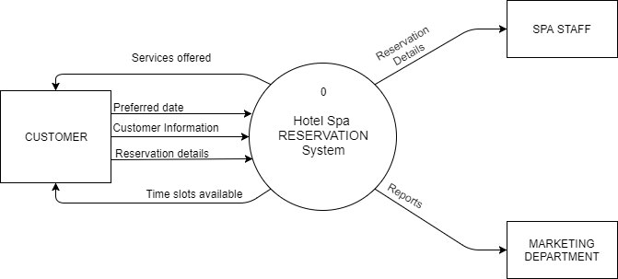**Context Diagram**

**Level 0 DFD**

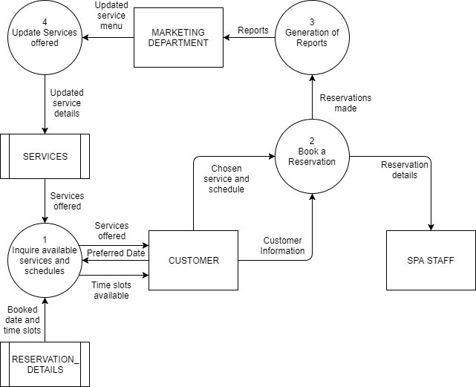

**Level 1 DFD for Process 1**

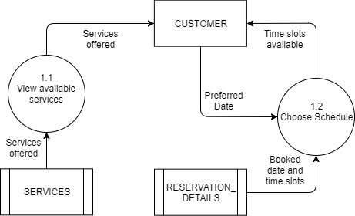

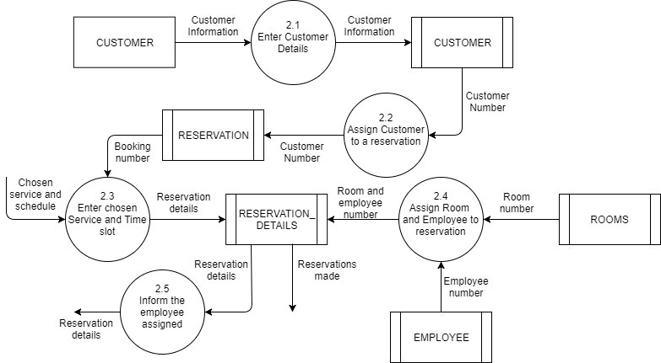**Level 1 DFD for Process 2**

**Data Specification**

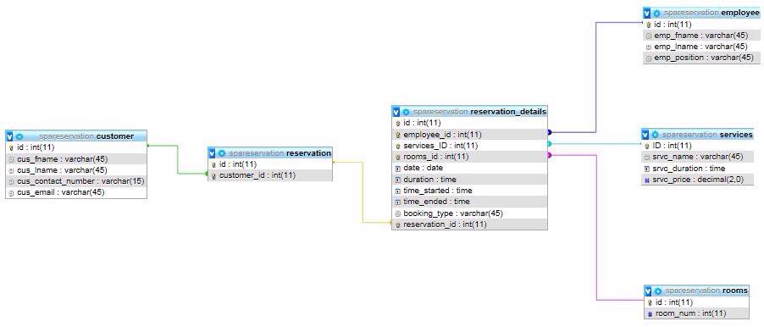**Entity-Relationship Diagram**

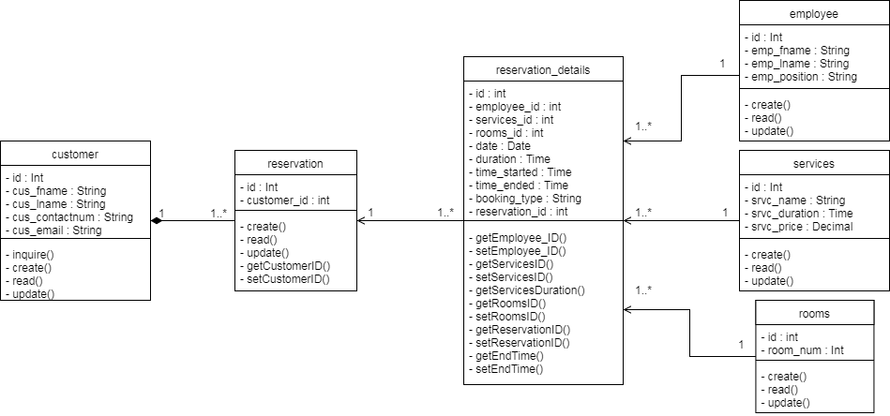**Class Diagram**

**Object Diagram**

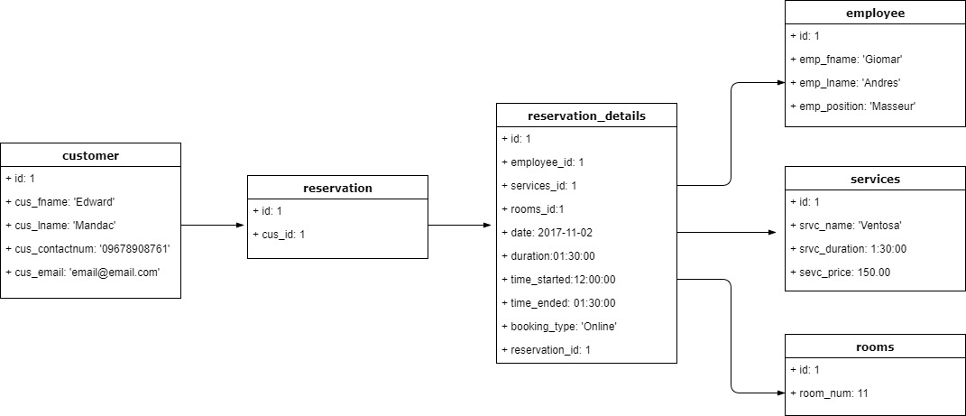

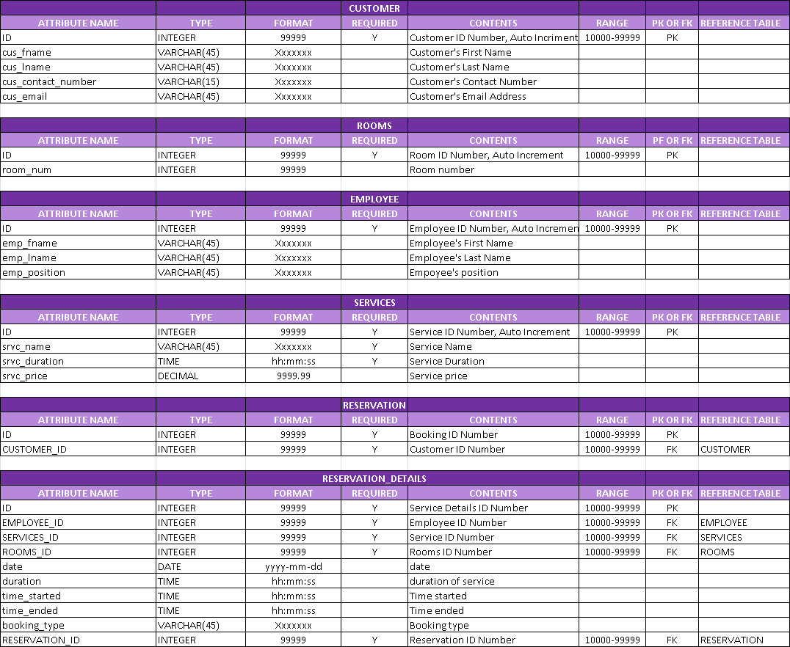**Data Dictionary**

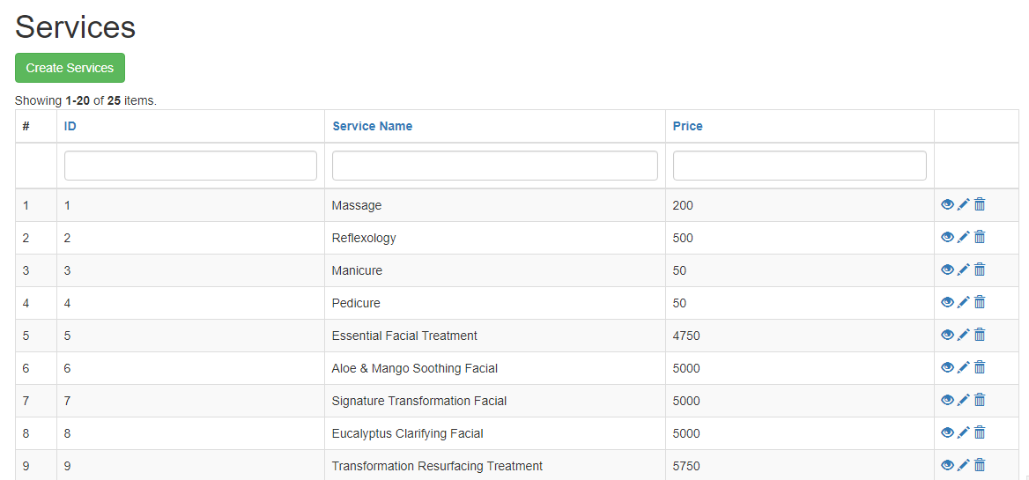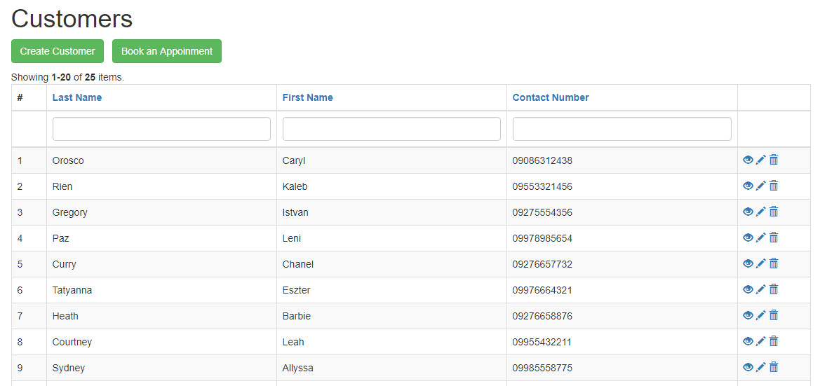 **Tables/Files Layout**

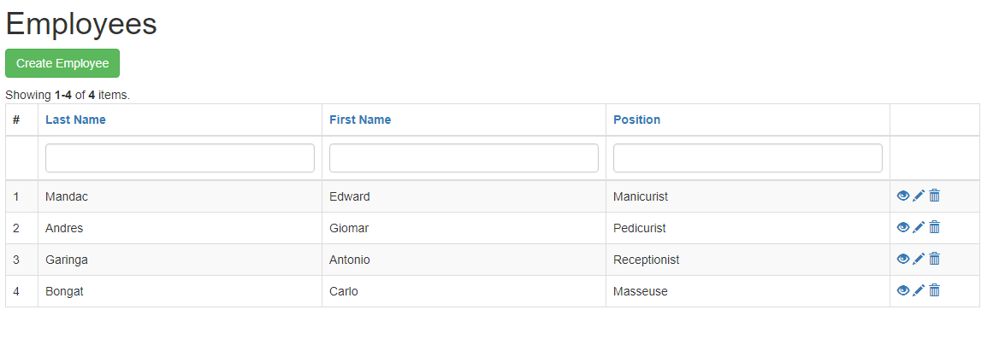

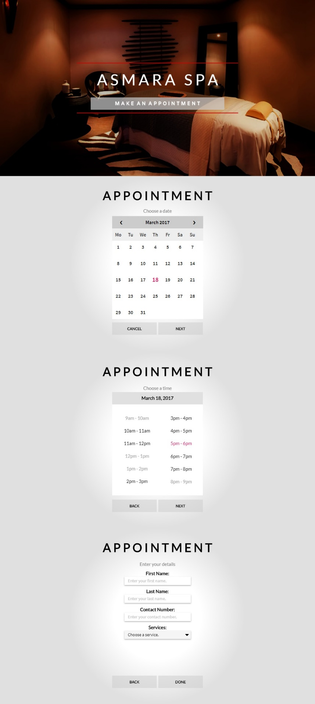**Screen Layout/Specifications**

**METHODOLOGY, RESULTS AND DISCUSSION**

**Requirement Documentation**

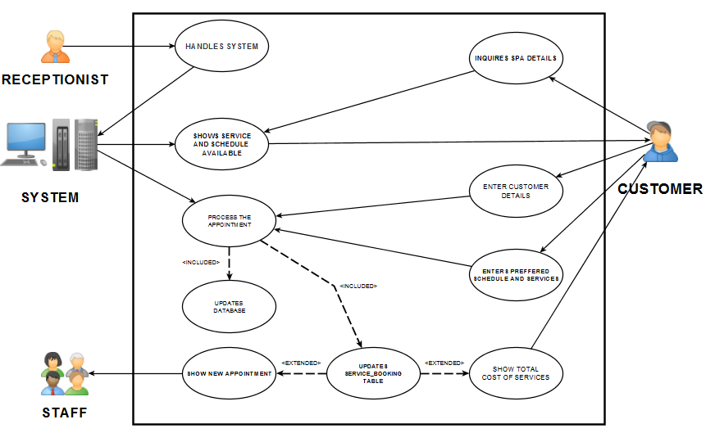  **Use Case Diagram**

**Fully Dressed Use Case**

**USE CASE UC1**: Process Schedule Appointment

**PRIMARY ACTOR:** Receptionist

**STAKEHOLDERS AND INTERESTS:**

* **Receptionist:** Wants accurate, fast entry and no appointment errors.
* **Customer:** Wants fast service with minimal effort.
* **Spa Company:** Wants to record transaction and satisfy customer interests. Wants to ensure customer and appointment details are recorded. Wants automatic and fast update of data.

**PRECONDITIONS:** Receptionist is identified/logged-in to the system.

**SUCCESS GUARANTEE:** Appointment Schedule is saved, Customer details are updated, Service Details are updated. Spa staff serves customer according to the preferred service.

**MAIN SUCCESS SCENARIO:**

1. Receptionist is logged into the system and is handling the system.
2. Customer checks the service details.
3. Customer enters his/her customer details and preferred appointment details.
4. Receptionist handles the system to process the appointment.
5. System processes the appointment details.
6. System updates the customer and service details.
7. System updates service booking.
8. System shows the total cost of service to the customer.
9. System shows the new appointment to the spa staff.
10. Customer goes to the Spa Company.
11. Receptionist confirms the customer details.
12. Spa staff serves the customer.

**EXTENSIONS:**

**\*A** anytime system fails:

1. Receptionist restarts system, logs in, and requests recovery.

**\*B** anytime customer decides to change appointment

1a. Customer asks the receptionist to cancel appointment.

2b. Customer tells the receptionist to change service.

**\*C** anytime customer decides to pay

1a. Customer pays by cash.

2a. Customer pays by card.

**Activity Diagram**

**Sequence Diagram**

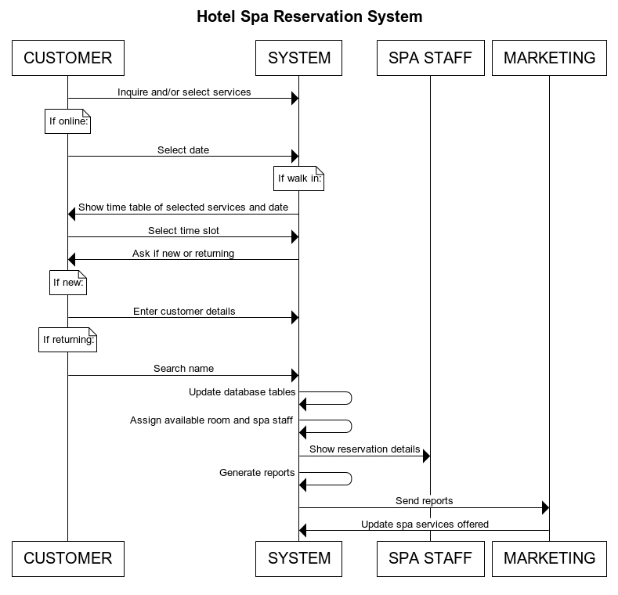

**Interaction Overview Diagram**

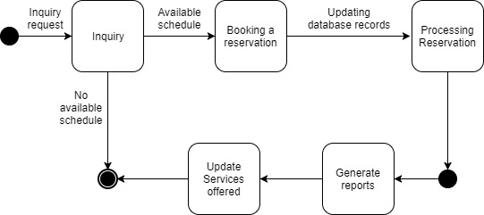**State Machine Diagram**

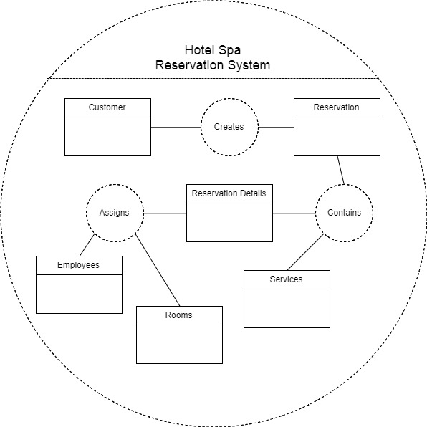**Composite Structure Diagram**

**Component Diagram**

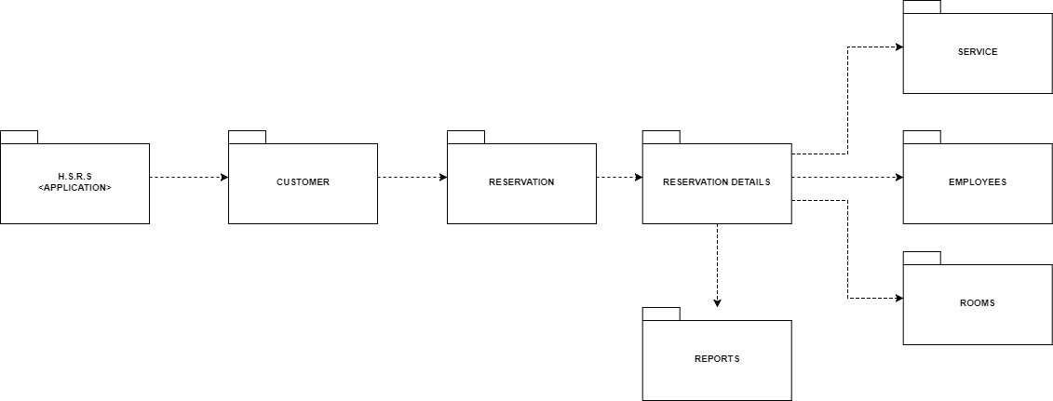**Package Diagram**

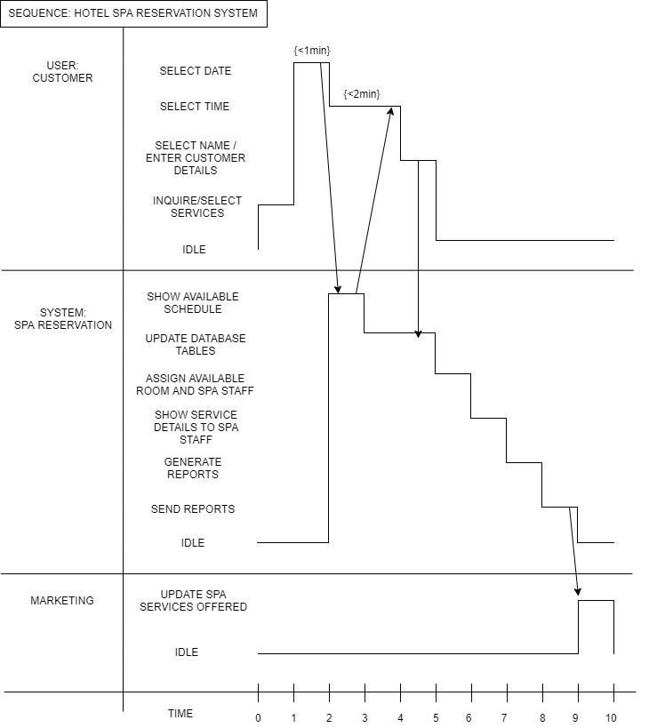**Timing Diagram**

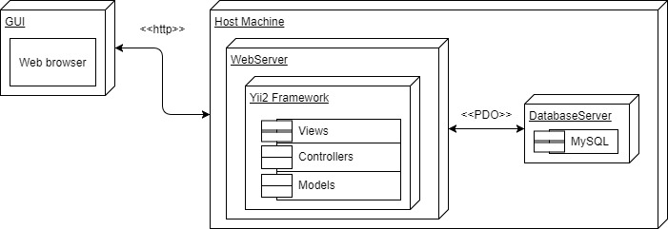**Deployment Diagram**

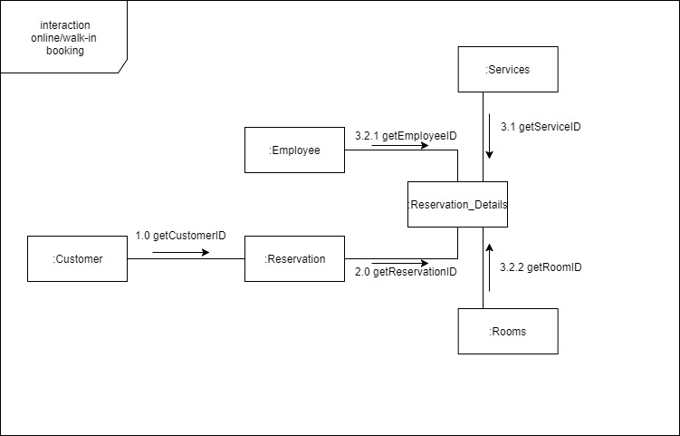**Communication Diagram**

**Gap Analysis**

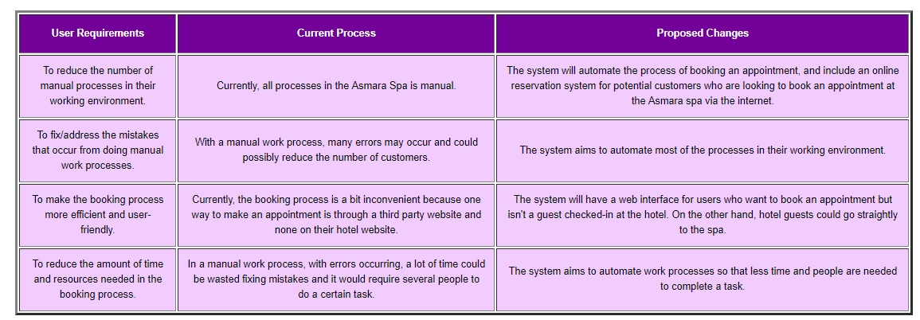

# Bibliography

(n.d.). Retrieved from Taal Vista Hotel: http://www.taalvistahotel.com/overview

Ambler, S.W. (n.d.). *Introduction to the Diagrams of UML 2.X.* Retreived from Agile Modeling: http://agilemodeling.com/essays/umlDiagrams.htm

Bodeker, M. C. (2008). *Understanding the Global Spa Industry: Spa Management.* Burlington: Elsevier Linacre House.

Corporation, A. (n.d.). *Fully-Dressed Use Case Sample.* Retrieved from https://image.slidesharecdn.com/slides-aras-plm-software-implementation-methodology-121023101444-phpapp02/95/aras-plm-software-implementation-methodology-38-638.jpg?cb=1350987433

Heesun Ki. (2016). A Study on Effects of Online Appointment Systems on Patiets and Hospitals. *International Journal of Applied Engineering Research*.

Omar Abdullah M. Al-Maktari, R. J.-S. (2012). The Acceptance of Online Booking System Based on the Theory of Reasoned Action. *International Journal of Scientific & Engineering Research*.

*PHP.* (n.d.). Retrieved from Wikipedia: https://en.wikipedia.org/wiki/PHP

Smith, R. (n.d.). *The Impact of Online Reservations Systems: For Chain Restaurants.*

*SQL.* (n.d.). Retrieved from Wikipedia: https://en.wikipedia.org/wiki/SQL